Cleaning and Analyzing Raw Daily Mandi Commodity Price Data to Improve Agricultural Market Price Intelligence and Forecasting

Contents
Abstract 3
1. Introduction 4
1.1 Background 4
1.2 Problem Statement 4
1.3 Business Value and Stakeholders 4
1.4 Scope of this Report 4
2. Objectives 5
3. Dataset 5
3.1 Source 5
3.2 Dataset Profile 6
3.3 Issues Found in the Raw Data 6
4. Methodology and Implementation 7
4.1 System Architecture 7
4.2 ETL Process in Python 7
4.3 Data Warehouse Design 8
4.4 SQL Analysis 9
4.5 Power BI Dashboard 10
5. Results and Findings 11
5.1 Overall Price Levels 11
5.2 Commodity Price Levels 11
5.3 Price Spread 13
5.4 Market Comparison 13
5.5 State Comparison 14
5.6 Variety and Grade 15
5.7 Summary of Findings 16
6. Data Quality Observations and Limitations 17
6.1 Coverage and Representativeness 17
6.2 Suspect Price Values 17
6.3 Items Planned in the Proposal and Not Yet Implemented 17
6.4 Dashboard Considerations 17
7. Conclusion 17
8. Future Scope 18
References 19
Appendix A: Project Repository 19
Appendix B: Selected SQL 20

Abstract
India's regulated agricultural markets, known as mandis, report daily minimum, maximum and modal wholesale prices. These reports are published through the AGMARKNET portal and the data.gov.in open data platform. The raw feed has encoded column names, inconsistent text and no persistent store, so comparing prices across markets takes manual effort.
This project builds a pipeline for a 7,181-record snapshot dated 28 July 2026. Python and pandas clean the data and add price spread measures. A MySQL star-schema warehouse with one fact table and five dimension tables stores the result, SQL queries answer seven business questions, and a Power BI dashboard presents the findings. The snapshot covers 20 states, 160 districts, 420 markets and 149 commodities.
The average modal price is Rs 5,519 per quintal and the average price spread is Rs 673. Among commodities with at least 20 records, marigold, mushrooms, garlic and apple have the highest average modal prices, and apple has the widest average spread at Rs 4,419. The snapshot holds a single date and 80.1 percent of its records come from Tamil Nadu, so the findings are descriptive and comparative. Forecasting is identified as future work that depends on accumulating daily snapshots.

1. Introduction

1.1 Background
Agricultural produce in India is sold wholesale through more than 3,000 regulated markets (mandis) spread across every state. Each market reports the minimum, maximum and modal price of the commodities traded that day. The modal price is the price that occurs most often in the market's trades, so it serves as the representative price for a commodity in that market.
The Directorate of Marketing and Inspection collects these reports and publishes them through the AGMARKNET portal. The Government of India re-publishes the same feed on data.gov.in under the National Data Sharing and Accessibility Policy.

1.2 Problem Statement
The feed is detailed but difficult to use directly. Prices are reported market by market, column names carry encoding artifacts such as _x0020_, text fields contain stray spaces, and grade labels follow different conventions for different commodities. The source publishes only the current day's prices, so no history builds up unless someone stores it. A trader, an APMC administrator or an analyst who wants to compare prices across markets, states or commodities has no single structured source to query.

1.3 Business Value and Stakeholders
A cleaned and structured price store serves several groups. State agricultural marketing boards and APMC administrators can monitor regional price levels and spreads. Traders, commission agents and Farmer Producer Organizations can compare markets before deciding where to buy or sell. Policy stakeholders can track price levels against support-price and price-stabilization measures, and agritech advisory platforms can use the data to recommend prices to farmers.
The source does not provide a volatility measure, so this project derives one. Price spread (maximum price minus minimum price) and price spread as a percentage of the modal price show how widely prices vary within a market on a given day.

1.4 Scope of this Report
This report covers the work completed for TAE-2: data cleaning in Python, the MySQL warehouse, the SQL analysis and the Power BI dashboard. The project title includes forecasting. The data collected so far has one arrival date, which is not enough to fit a time-series model, so forecasting is treated as the next phase and described in Section 8.

2. Objectives
The project has the following objectives:
- Clean and preprocess the raw commodity price data.
- Implement the extract, transform and load (ETL) process in Python.
- Build a MySQL data warehouse with a star schema of fact and dimension tables.
- Answer analytical business questions with SQL.
- Derive price spread and price spread percentage as measures of price variation.
- Build an interactive Power BI dashboard connected to the warehouse.
- Record the findings and limitations, and define the data needed for forecasting.

3. Dataset

3.1 Source
The dataset is the "Current Daily Price of Various Commodities for Various Markets (Mandi)" resource published on data.gov.in. The file was pulled through the data.gov.in API with a personal API key, and it was not taken from a third-party repository. The price column headers keep the source encoding (for example Min_x0020_Price), which shows that no earlier cleaning was applied.
Table 1: Dataset identity
Item | Detail
Dataset name | Current Daily Price of Various Commodities for Various Markets (Mandi)
Publisher | Directorate of Marketing and Inspection, Department of Agriculture and Farmers Welfare, Government of India (AGMARKNET portal)
Catalog page | https://www.data.gov.in/catalog/current-daily-price-various-commodities-various-markets-mandi
API resource | https://api.data.gov.in/resource/9ef84268-d588-465a-a308-a864a43d0070
License | National Data Sharing and Accessibility Policy (NDSAP)
Arrival date | 28 July 2026 (single date)
Price unit | Rs per quintal

3.2 Dataset Profile
Table 2: Profile of the raw dataset
Measure | Value
Total records | 7,181
States | 20
Districts | 160
Markets (mandis) | 420
Distinct commodities | 149
Distinct varieties | 218
Distinct grade labels | 12
Columns in the raw file | 10

Table 3: Columns in the raw file
Column | Meaning
State, District, Market | Location of the market (mandi)
Commodity, Variety, Grade | What is traded and its quality label
Arrival_Date | Date of market arrival (dd/mm/yyyy text)
Min_x0020_Price | Lowest price reported for the commodity in that market
Max_x0020_Price | Highest price reported for the commodity in that market
Modal_x0020_Price | Most common (representative) traded price

3.3 Issues Found in the Raw Data
Profiling the raw file showed no null values and no duplicate rows. It did show several formatting and consistency problems, listed below together with how this project dealt with each one.
Table 4: Raw data issues and their treatment
Issue | Observation | Treatment
Encoded column headers | Price columns named Min_x0020_Price, Max_x0020_Price and Modal_x0020_Price | Renamed to min_price, max_price and modal_price
Stray spaces in text | Leading or trailing spaces in 23 District, 26 Market, 35 Commodity and 32 Variety values | Stripped from every text column
Date stored as text | Arrival_Date held as dd/mm/yyyy strings | Converted to datetime; no value failed conversion
Grade labels | 12 labels that follow different conventions (FAQ, Grade A, Local, Large and others) | Kept as reported; standardization listed as future work
Commodity and variety names | Related names stored separately (for example Mango and Mango(Raw-Ripe)) | Kept as reported
Single-day snapshot | One arrival date for all 7,181 records | Recorded as a limitation (Section 6)

4. Methodology and Implementation

4.1 System Architecture
The pipeline has seven stages. The raw CSV is read and cleaned in a Jupyter notebook, and the cleaned file is loaded into a staging table in MySQL. The dimension and fact tables are then populated from the staging table. SQL queries run against the star schema, and Power BI connects to the same warehouse for the dashboard.
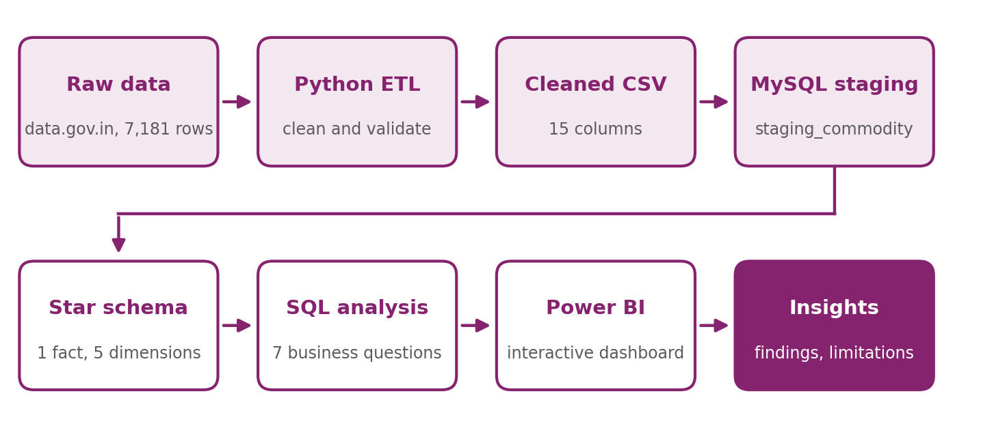
Figure 1: End-to-end pipeline

4.2 ETL Process in Python
The ETL work is in the notebook 01_ETL.ipynb and uses pandas and NumPy.
Extract. The raw CSV was read with pandas. The file has 7,181 rows and 10 columns. The three price columns were already numeric and the date column was text.
Transform. The following changes were applied to a copy of the data:
- Column names were cleaned by replacing _x0020_ with an underscore, trimming spaces and converting to lower case.
- Leading and trailing spaces were removed from all text columns.
- arrival_date was converted to a datetime type.
- The three price columns were converted to numeric types.
- price_spread was calculated as max_price minus min_price.
- price_spread_pct was calculated as price_spread divided by modal_price, multiplied by 100.
- year, month and day were extracted from arrival_date.

Validate. Table 5 lists the checks run on the transformed data. All of them passed.
Table 5: Data validation checks
Check | Result
Missing values in any column | 0
Duplicate rows | 0
Rows where min_price is greater than modal_price | 0
Rows where modal_price is greater than max_price | 0
Rows with a negative price | 0
Distinct arrival dates | 1 (28 July 2026)

Load. The final dataset has 7,181 rows and 15 columns and was saved as commodity_cleaned.csv. No records were removed during cleaning.

4.3 Data Warehouse Design
The warehouse uses a star schema, which separates the measurable values (the fact table) from the descriptive attributes (the dimension tables). The fact table holds the prices and the price spread measures, and each dimension table describes who, what, where or when for a price record. This layout keeps the analytical queries short because each one joins the fact table to a single dimension and groups the result.
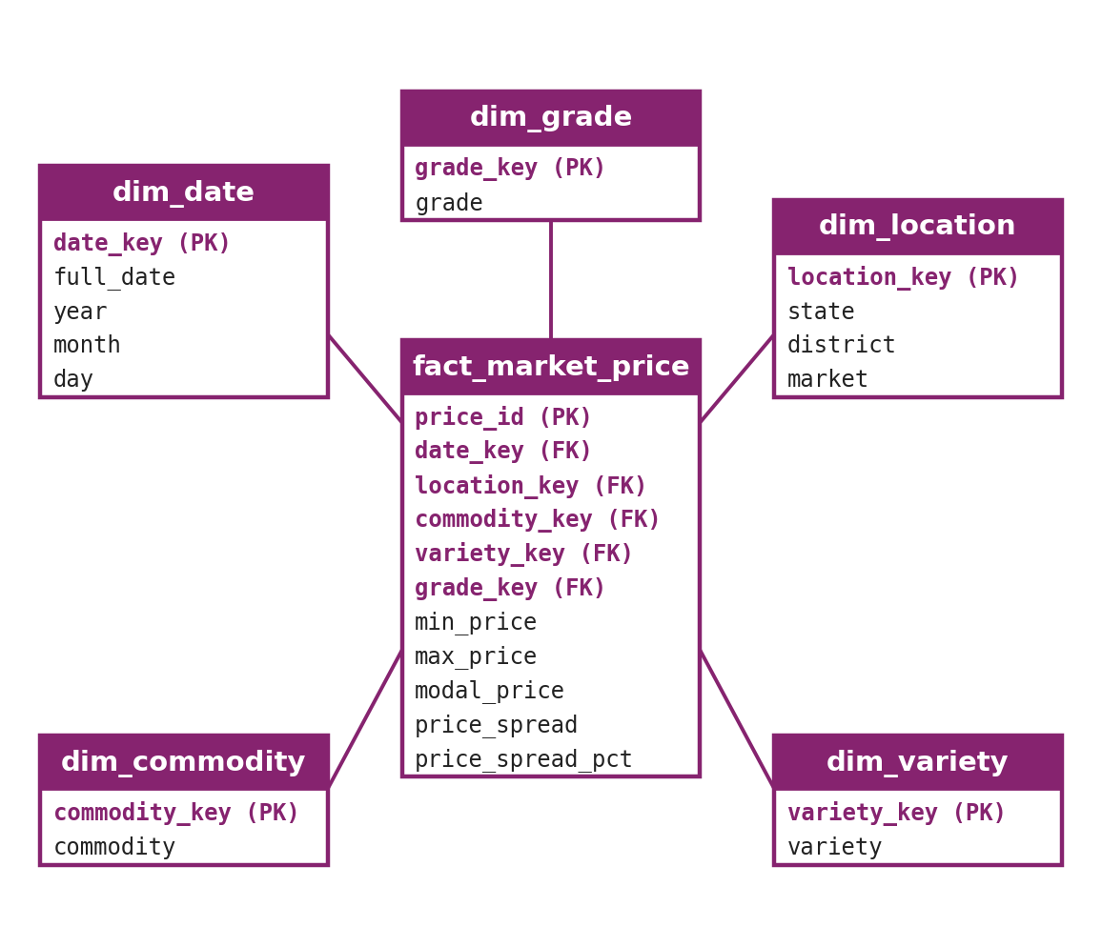
Figure 2: Star schema of the commodity_price_dw database
The grain of the fact table is one row for each combination of market, commodity, variety and grade on the arrival date. This combination is unique in the data. Table 6 summarizes the tables and their row counts, which come from the warehouse export.
Table 6: Warehouse tables and row counts
Table | Content | Rows
dim_date | date_key (YYYYMMDD), full_date, year, month, day | 1
dim_location | location_key, state, district, market | 420
dim_commodity | commodity_key, commodity | 149
dim_variety | variety_key, variety | 218
dim_grade | grade_key, grade | 12
fact_market_price | Foreign keys to the five dimensions; min_price, max_price, modal_price, price_spread, price_spread_pct | 7,181

The load followed four steps. A staging table with the same columns as the cleaned CSV was created and filled using the MySQL Workbench import. Each dimension table was then filled with an INSERT ... SELECT DISTINCT statement on the staging table, and date_key was built as year x 10000 + month x 100 + day, which gives 20260728 for this snapshot. The fact table was filled by joining the staging table to the five dimensions on their natural values. Foreign key constraints on the fact table enforce referential integrity. The fact table holds 7,181 rows, the same count as the cleaned CSV, so none of the joins dropped a record.

4.4 SQL Analysis
Seven analytical queries were written against the star schema. Each joins the fact table to one dimension and aggregates with GROUP BY. Table 7 lists the business question behind each query and where the result appears on the dashboard.
Table 7: Business questions answered with SQL
No. | Business question | Calculation | Dashboard visual
1 | Which commodities have the highest average modal price? | AVG(modal_price) by commodity | Bar chart
2 | Which markets have the highest average modal price? | AVG(modal_price) by market | Bar chart
3 | Which commodities have the largest price spread? | AVG(price_spread) by commodity | Bar chart
4 | Which states have the highest average modal price? | AVG(modal_price) by state | State slicer only
5 | How do minimum, maximum and modal prices compare? | AVG of the three prices by commodity | Clustered column chart
6 | Which varieties have the highest average modal price? | AVG(modal_price) by variety | Not on the dashboard
7 | How do grades compare in price and variation? | COUNT, AVG(modal_price), AVG(price_spread) by grade | Grade slicer

The query for the first question is shown below. The other queries follow the same pattern, and the full script is in the SQL folder of the project repository.
SELECT
c.commodity,
ROUND(AVG(f.modal_price), 2) AS avg_modal_price
FROM fact_market_price f
JOIN dim_commodity c
ON f.commodity_key = c.commodity_key
GROUP BY c.commodity
ORDER BY avg_modal_price DESC;

4.5 Power BI Dashboard
The dashboard is a single page built in Power BI Desktop and connected to the MySQL warehouse through the MySQL connector. Figure 3 shows the finished page.
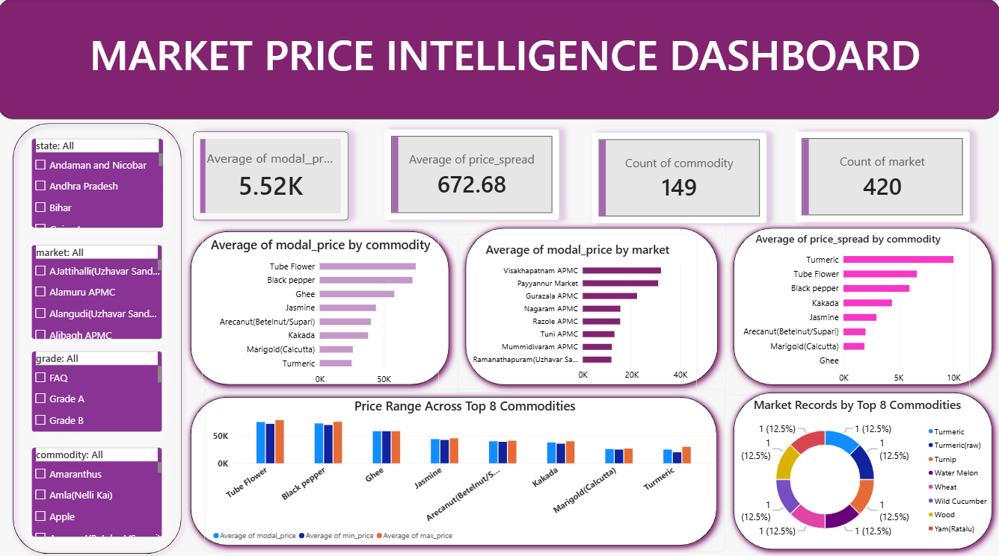
Figure 3: Market Price Intelligence Dashboard (Power BI)
A banner at the top carries the title. The panel on the left holds four slicers for state, market, grade and commodity, and a selection in any slicer filters every visual on the page. Four KPI cards show the average modal price (5.52K), the average price spread (672.68), the count of commodities (149) and the count of markets (420). These figures agree with the warehouse, where the mean modal price is Rs 5519.21 and the mean price spread is Rs 672.68.
The rest of the page holds the analytical visuals. Three bar charts rank commodities by average modal price, markets by average modal price, and commodities by average price spread, each showing the top eight entries. A clustered column chart compares the average modal, minimum and maximum price for eight commodities. A donut chart shows the number of records for a set of eight commodities.

5. Results and Findings
The figures in this section were calculated from the cleaned dataset using the same grouping logic as the SQL queries. Where a ranking is shown, commodities and markets with very few records are handled explicitly, because an average over one or two records describes only those reports.

5.1 Overall Price Levels
Table 8: Summary statistics for the price columns (Rs per quintal)
Statistic | Min price | Max price | Modal price | Price spread
Mean | 5,182 | 5,855 | 5,519 | 673
Median | 4,000 | 4,500 | 4,300 | 500
Minimum | 1 | 1 | 1 | 0
Maximum | 100,000 | 105,000 | 102,500 | 21,000

The average modal price is Rs 5,519 per quintal against a median of Rs 4,300. The mean sits above the median because a small number of high-value commodities, mainly flowers, spices and ghee, pull the average up. 11 records have a modal price of Rs 50,000 or more. The average price spread is Rs 673, which is 13.5 percent of the modal price, and the median spread is Rs 500 (10.7 percent).

5.2 Commodity Price Levels
To rank commodities fairly, Table 9 and Figure 4 include only the 68 commodities that have at least 20 records. Marigold has the highest average modal price at Rs 25,889, followed by mushrooms, garlic and apple. At the other end of this group, pumpkin (Rs 2,064), tomato (Rs 2,106) and watermelon (Rs 2,132) have the lowest averages. Commodity names are shown as spelled in the source data.
Table 9: Top 10 commodities by average modal price (at least 20 records)
Commodity | Records | Avg min | Avg modal | Avg max
Marigold(Calcutta) | 22 | 24,936 | 25,889 | 26,841
Mashrooms | 23 | 20,896 | 21,633 | 22,370
Garlic | 77 | 18,095 | 19,328 | 20,522
Apple | 49 | 15,971 | 18,227 | 20,390
Rose(Local) | 20 | 17,000 | 17,675 | 18,350
Ginger(Green) | 130 | 16,494 | 17,640 | 18,785
Pomegranate | 38 | 15,776 | 16,882 | 17,961
Tamarind Fruit | 25 | 11,672 | 12,204 | 12,736
Orange | 21 | 11,048 | 12,012 | 12,976
Grapes | 26 | 9,435 | 9,813 | 10,231

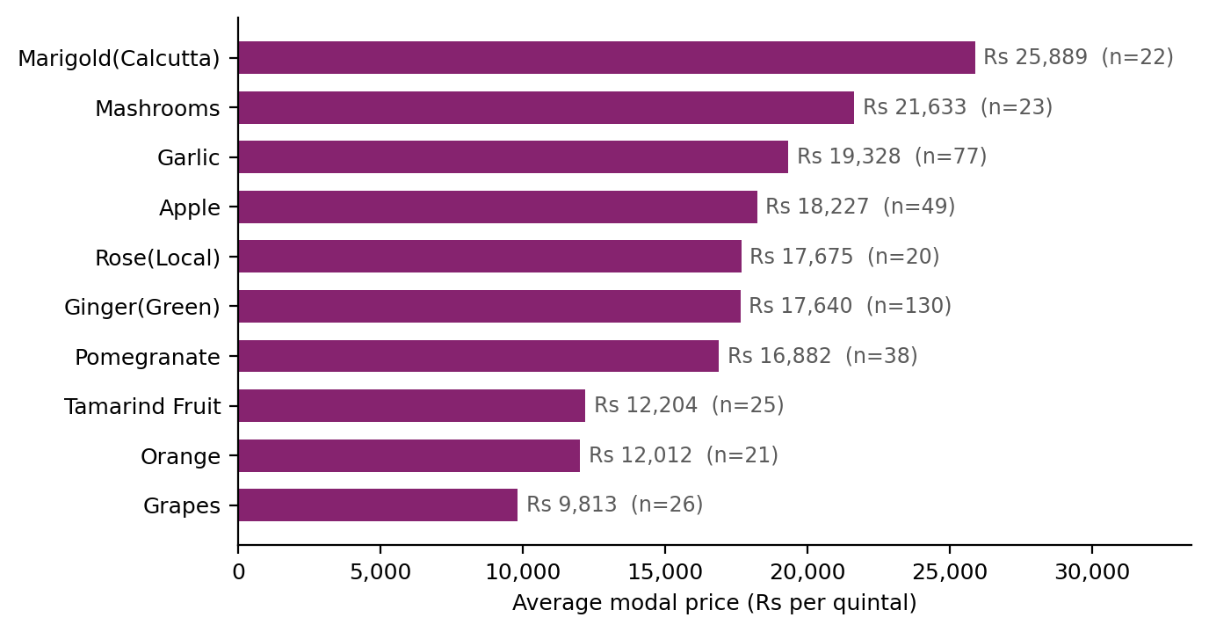
Figure 4: Average modal price of the top 10 commodities with at least 20 records
The dashboard ranks commodities by average modal price without a minimum record count, so its leading entries differ from the list above. Table 10 shows the five highest averages across all 149 commodities together with the number of records behind each one.
Table 10: Highest average modal prices without a minimum record count
Commodity | Records | Avg modal price
Tube Flower | 3 | 75,000
Black pepper | 2 | 72,500
Ghee | 1 | 58,250
Jasmine | 12 | 43,917
Arecanut(Betelnut/Supari) | 1 | 40,000

Tube flower, black pepper, ghee and arecanut rest on one to three records each, and jasmine on 12. These averages describe individual reports from a few markets and do not represent a national price level for the commodity. 45 of the 149 commodities have three or fewer records.

5.3 Price Spread
Price spread measures the gap between the highest and lowest price reported for a commodity in a market. Table 11 ranks commodities with at least 20 records by average spread and also shows the spread as a percentage of the modal price.
Table 11: Top 8 commodities by average price spread (at least 20 records)
Commodity | Records | Avg spread (Rs) | Avg spread (% of modal)
Apple | 49 | 4,419 | 28.3
Garlic | 77 | 2,427 | 13.0
Ginger(Green) | 130 | 2,290 | 14.4
Pomegranate | 38 | 2,184 | 15.6
Orange | 21 | 1,929 | 16.8
Marigold(Calcutta) | 22 | 1,905 | 6.9
Mashrooms | 23 | 1,474 | 7.1
Rose(Local) | 20 | 1,350 | 8.9

Apple has the widest spread both in rupees (Rs 4,419) and in relative terms (28.3 percent of the modal price). Cucumber (24.9 percent) and mango (24.3 percent) follow in relative terms. Marigold has the highest average price among the commodities with 20 or more records but a narrow spread of 6.9 percent, so a high price level does not imply a wide spread.
A wide spread within one day's report can reflect differences in quality between lots as well as price instability. The data has no lot-level detail that would separate the two. The spread ranking on the dashboard, which also has no minimum record count, shows the same pattern as the price ranking: its leading entries are commodities with very few records.

5.4 Market Comparison
Across all 420 markets the median number of records is 6, and 224 markets have fewer than 10 records. Table 12 therefore limits the comparison to the 196 markets with at least 10 records.
Table 12: Top 8 markets by average modal price (at least 10 records)
Market | State | Records | Avg modal price
Ramanathapuram(Uzhavar Sandhai) | Tamil Nadu | 43 | 11,743
The Agricultural Produce Market Committee-Amreli | Gujarat | 10 | 10,478
Chala Market | Keralam | 16 | 10,000
Paramakudi(Uzhavar Sandhai) | Tamil Nadu | 41 | 9,695
Perambakkam(Uzhavar Sandhai) | Tamil Nadu | 12 | 9,542
Diglipur Vegetable Market (Subhashgram) | Andaman and Nicobar | 23 | 8,786
Anna nagar(Uzhavar Sandhai) | Tamil Nadu | 64 | 8,297
Manubazar | Tripura | 20 | 8,165

Ramanathapuram (Uzhavar Sandhai) in Tamil Nadu has the highest average at Rs 11,743 on 43 records. Three of the four highest modal prices in the whole dataset were reported there: tube flower at Rs 102,500, jasmine at Rs 72,500 and kakada at Rs 72,500. A market's average therefore reflects the commodities it reports as much as the level of its prices. Without the record filter, the dashboard's market ranking is led by Visakhapatnam APMC, Payyannur Market and Gurazala APMC, which have two, four and two records.

5.5 State Comparison
Table 13 lists all 20 states in order of record count. The distribution is uneven: Tamil Nadu contributes 5,754 records (80.1 percent of the dataset) from 151 markets.
Table 13: State-wise records and average prices
State | Records | Markets | Avg modal price | Avg spread
Tamil Nadu | 5,754 | 151 | 5,742 | 623
Punjab | 240 | 18 | 3,650 | 650
Keralam | 218 | 20 | 6,321 | 602
Andhra Pradesh | 183 | 116 | 5,238 | 388
Haryana | 152 | 11 | 4,585 | 1,630
Gujarat | 102 | 14 | 5,590 | 2,074
Himachal Pradesh | 99 | 7 | 5,560 | 1,414
Maharashtra | 60 | 6 | 3,849 | 1,175
Telangana | 57 | 13 | 2,982 | 220
Uttar Pradesh | 55 | 11 | 2,237 | 416
Uttarakhand | 47 | 5 | 1,557 | 573
West Bengal | 46 | 5 | 5,236 | 293
Madhya Pradesh | 35 | 18 | 2,275 | 163
Rajasthan | 30 | 9 | 2,919 | 409
Odisha | 29 | 6 | 3,445 | 548
Tripura | 25 | 2 | 7,812 | 536
Andaman and Nicobar | 23 | 1 | 8,786 | 3,937
Bihar | 21 | 5 | 2,430 | 218
Nagaland | 3 | 1 | 3,333 | 0
Jammu and Kashmir | 2 | 1 | 1,600 | 0

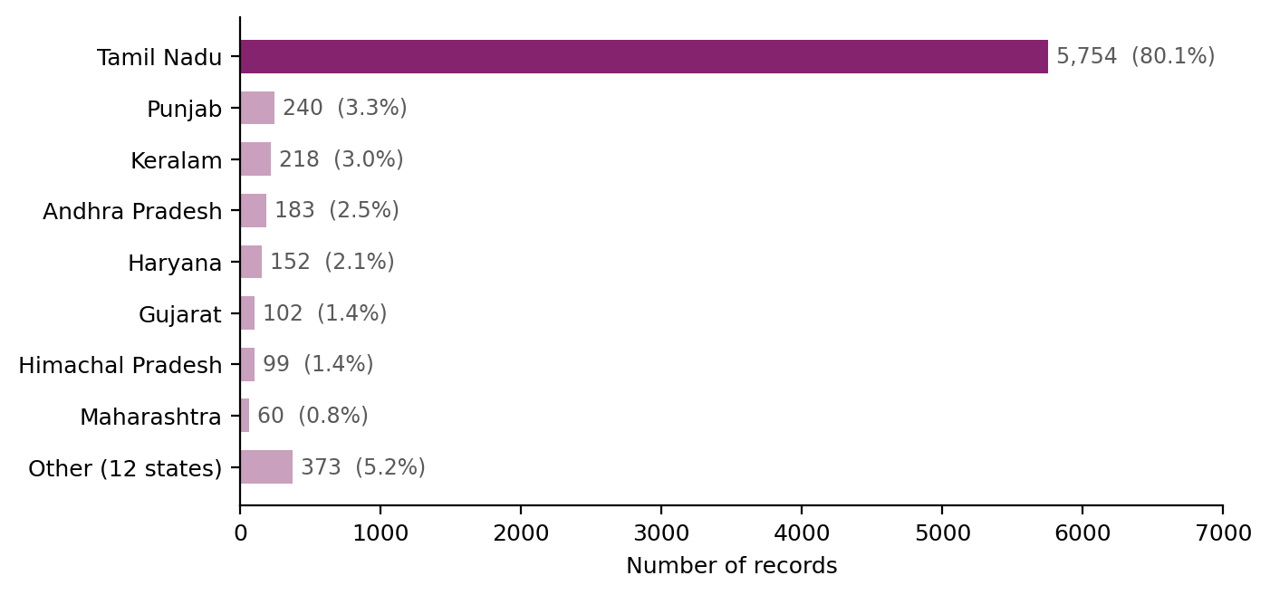
Figure 5: Share of records by state
Andaman and Nicobar has the highest average modal price at Rs 8,786, but it comes from 23 records at a single market. Tripura follows with 25 records from two markets. Keralam (218 records) and Tamil Nadu (5,754 records) have enough data for a more stable average. State averages depend on which commodities each state reported, so states with few records should be read with caution.

5.6 Variety and Grade
Among varieties with at least 20 records, marigold (Calcutta), American apple, mushrooms, garlic, green ginger and pomegranate have the highest average modal prices, which matches the commodity ranking in Table 9.
Table 14 shows the six most common grades. The label "Local" covers 84.9 percent of the records.
Table 14: Average price and spread for the six most common grades
Grade | Records | Share (%) | Avg modal price | Avg spread
Local | 6,099 | 84.9 | 5,660 | 623
FAQ | 589 | 8.2 | 4,382 | 883
Medium | 272 | 3.8 | 4,566 | 1,171
Grade A | 79 | 1.1 | 3,600 | 275
Grade B | 79 | 1.1 | 5,110 | 1,450
Grade Range-1 | 16 | 0.2 | 19,681 | 1,998

Grade labels follow different conventions for different commodities, so the average price by grade mostly reflects which commodities carry each label. Grade Range-1, for example, averages Rs 19,681 on 16 records, a figure set by the commodities that use that label. A grade comparison is meaningful only within one commodity, and that analysis needs a standardized grade scale.

5.7 Summary of Findings
- The average modal price is Rs 5,519 per quintal and the median is Rs 4,300, which shows a right-skewed distribution driven by a few high-value commodities.
- Among commodities with at least 20 records, marigold, mushrooms, garlic and apple have the highest average modal prices, and pumpkin, tomato and watermelon have the lowest.
- Apple has the widest price spread at Rs 4,419 on average, or 28.3 percent of its modal price.
- Market and state averages largely reflect the commodity mix that each market or state reported.
- Rankings built on commodities or markets with one to four records are unreliable and should carry a minimum record count.

6. Data Quality Observations and Limitations

6.1 Coverage and Representativeness
The dataset holds a single arrival date, so it supports comparison across commodities, markets and states but not analysis of trends or seasonality. Coverage across the country is uneven. Tamil Nadu supplies 80.1 percent of the records and 151 of the 420 markets, while Andhra Pradesh has 116 markets but only 183 records. Across commodities, 68 have at least 20 records and 45 have three or fewer.
1,635 records (22.8 percent) have equal minimum and maximum prices and therefore a spread of zero. These are markets that reported a single price, and they pull the average spread downward.

6.2 Suspect Price Values
The validation checks confirmed that prices are in logical order, but they cannot detect values that are internally consistent and still implausible. Five records from Patti APMC report Rs 1 as the minimum, maximum and modal price for brinjal, tomato, green chilli, cucumber and potato. In total 16 records have a modal price below Rs 100. 28 records have a spread larger than the modal price itself, and the largest is a cucumber record at Gulavati APMC (Uttar Pradesh) with a minimum of Rs 1,500, a maximum of Rs 17,000 and a modal price of Rs 1,600, a spread of 969 percent.
These records remain in the cleaned dataset and in the warehouse. Their effect on the overall average is small: the mean modal price is Rs 5519.21 with them and Rs 5531.51 without the 16 records priced under Rs 100. A global outlier rule would be unsuitable because price levels differ by more than a factor of ten between commodities, so any outlier check has to work within each commodity.

6.3 Items Planned in the Proposal and Not Yet Implemented
The TAE-1 proposal described three steps that are not part of the current implementation: standardizing the 12 grade labels into one scale, reconciling commodity and variety names, and applying outlier checks within each commodity. The proposed Dim_Date attributes (week, quarter, reporting-day flag) and a commodity category attribute are also absent. The current warehouse works as a descriptive store for one date, and these steps become more valuable once several dates are loaded.

6.4 Dashboard Considerations
The three ranking charts on the dashboard show the top eight entries by average value with no minimum record count. As Sections 5.2 to 5.4 show, this puts commodities and markets with one to four records at the top. Adding a minimum record filter, or showing the record count next to each bar, would make the rankings reliable. The state dimension is available only as a slicer, and a state-wise chart or map would present the state comparison directly.

7. Conclusion
The project turns a raw daily price feed into a structured warehouse and an interactive dashboard. The ETL step kept all 7,181 records, standardized column names and data types, removed stray spaces, and added price spread measures. The star schema loaded every record into the fact table, and the seven SQL queries answered the business questions set at the start.
The analysis shows a wide range of price levels. Among commodities with at least 20 records, the average modal price runs from about Rs 2,064 per quintal for pumpkin to about Rs 25,889 for marigold. Apple shows the widest spread, and market and state averages mostly follow the commodity mix. The uneven coverage, the small number of records behind many rankings and a handful of implausible prices limit how far the findings generalise, and Section 6 records these limits. With a single date, the work is descriptive and comparative. It also establishes the pipeline and schema on which a multi-date history and a forecasting model can be built.

8. Future Scope
- Build a history. Schedule daily pulls from the data.gov.in API into the staging table and the warehouse, and extend Dim_Date with week, quarter and a reporting-day flag. The source is not updated on Sundays and has occasional gaps, so the load should record which days are missing.
- Improve data quality. Add outlier checks within each commodity group, a lookup table that maps the 12 grade labels to one scale, and a reconciliation of commodity and variety names. Add a commodity category to Dim_Commodity.
- Strengthen the dashboard. Apply a minimum record filter to the rankings, show record counts beside each bar, and add a state-wise chart or map.
- Add trend measures. Once several dates are loaded, calculate day-on-day and week-on-week price change and a measure of reporting completeness for each market.
- Forecast prices. Fit time-series models such as ARIMA, SARIMA and Prophet to the accumulated history. The studies reviewed in the proposal also evaluated gradient-boosted trees and LSTM and GRU networks on AGMARKNET data.
- Add external variables. One of the reviewed studies reported better forecasts for tomato, onion and potato when weather variables were added to the price history, so weather, demand-supply and transport cost data are candidates for later phases.

References
[1] Directorate of Marketing and Inspection, Department of Agriculture and Farmers Welfare, Government of India. "Current Daily Price of Various Commodities for Various Markets (Mandi)." data.gov.in. https://www.data.gov.in/catalog/current-daily-price-various-commodities-various-markets-mandi
[2] AGMARKNET, Agricultural Marketing Information Network. Government of India. https://agmarknet.gov.in
[3] "Enhancing agricultural commodity price forecasting with deep learning." Scientific Reports, 2025.
[4] "Exogenous variable driven deep learning models for improved price forecasting of TOP crops in India." Scientific Reports, 2024.

Appendix A: Project Repository
The project files are available at https://github.com/DevyaniGit009/Market-Price-Intelligence-and-Forecasting. Table 15 describes the contents.
Table 15: Repository contents
File or folder | Contents
Data/Raw/Commodity_dataset_raw.csv | Raw daily snapshot, 7,181 rows and 10 columns
Data/Processed/commodity_cleaned.csv | Cleaned dataset, 15 columns
Data/Processed/commodity_price_dw.xlsx | Export of the six warehouse tables
Notebooks/01_ETL.ipynb | Python ETL notebook
SQL/commodity_dw.sql | Warehouse tables, load statements and analysis queries
Dashboard/Market price intelligence Dashboard.pbix | Power BI dashboard
PPT/BI tae 2.pdf | TAE-2 presentation
Proposal report/ | TAE-1 proposal

Appendix B: Selected SQL
Loading the fact table from the staging table and the five dimensions:
INSERT INTO fact_market_price (
date_key, location_key, commodity_key, variety_key, grade_key,
min_price, max_price, modal_price, price_spread, price_spread_pct)
SELECT d.date_key, l.location_key, c.commodity_key,
v.variety_key, g.grade_key,
s.min_price, s.max_price, s.modal_price,
s.price_spread, s.price_spread_pct
FROM staging_commodity s
JOIN dim_date d ON d.full_date = s.arrival_date
JOIN dim_location l ON l.state = s.state
AND l.district = s.district
AND l.market = s.market
JOIN dim_commodity c ON c.commodity = s.commodity
JOIN dim_variety v ON v.variety = s.variety
JOIN dim_grade g ON g.grade = s.grade;
Comparing grades by record count, average modal price and average price spread:
SELECT
g.grade,
COUNT(*) AS number_of_records,
ROUND(AVG(f.modal_price), 2) AS avg_modal_price,
ROUND(AVG(f.price_spread), 2) AS avg_price_spread
FROM fact_market_price f
JOIN dim_grade g ON f.grade_key = g.grade_key
GROUP BY g.grade
ORDER BY avg_modal_price DESC;
A minimum record count can be added to any ranking query with a HAVING clause, for example HAVING COUNT(*) >= 20, which produces the filtered rankings used in Section 5.

